**Why do we need Desired Capabilities?**

**Desired Capabilities** are needed because every[Testing](https://www.guru99.com/software-testing.html)scenario should be executed on some specific testing environment. The testing environment can be a web browser,[Mobile](https://www.guru99.com/mobile-testing.html)device, mobile emulator, mobile simulator, etc. The Desired Capabilities Class helps us to tell the webdriver, which environment we are going to use in our test script.

**Ex: Grid**

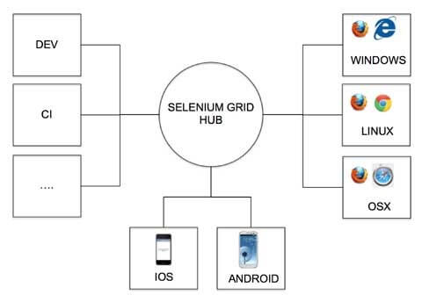

It is used to set the browser properties (Ex. Chrome, IE), Platform Name (Ex. Linux, Windows) that are used while executing the test cases.

In the case of mobile automation, as we perform the tests on different varieties of mobile devices, the Mobile Platform (ex. iOS, Android) Platform Version (Ex. 3.x,4.x in Android) can be set.